## Introduction to Computer Programming in Java and Program Architecture

### Extra Resources

The New Boston (YouTube): https://www.youtube.com/playlist?list=PLFE2CE09D83EE3E28

### File sharing

Sign up at: *http://www.github.com/*

All of our **code** will be available here: *https://github.com/RoboEagles/2015RobotCode*

All preseason **test code** will be here: *https://github.com/RoboEagles/2015RobotTest*

### Programming

#### Syntax and Semantics

Figure 1 - Basic Java Syntax

#### Variables and Data Types

* Four main variable types that we will work with (there are others)
  + String – a “string” of characters, declared with: $String$ (capitalization counts!)
  + Integer – a whole number above or below zero, declared with: $int$
  + Double – a decimal number above or below zero, declared with: $double$
  + Boolean – a binary value, either $true$ or $false$, declared with: $boolean$

#### Functions

* Functions are sets (“blocks”) of code that you run to perform a specific operation
* A function can return a value of your choice. Typically a function return is the value of the computation within the function. To return a value means to bring that value back to where the function was called to in Java.
* A function can take function parameters to do its computation. For example, a function to add might take two integer value arguments.

#### Object Oriented Programming

* Classes are Java objects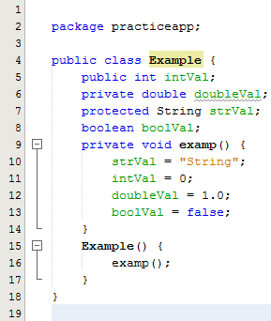
* Methods and Properties are assigned to an object
* We create class variables (objects), which are instances of classes. We call them like this:

$AnyClass objectName=new AnyClass();$

* Objects have constructors which run anytime an instance of that class is created.

Figure 2 - A Simple Java Class

#### Variable Scope and Object Properties

* Object Inheritance
  + Subclasses are classes that “extend” another class. For example, all of the different commands we program will be written as: $public class CommName extends Command \{$
    - A good example of extension is: Cat and Dog are subclasses of Animal
* Scopes
  + Public scope [$public$] – Can be accessed among anything in Java Universe (all packages)
  + Private scope [$private$] – Can only be used in the class that the property is called in
  + Protected scope [$protected$] – Can be accessed in subclasses of that class
  + No scope identifier – Visible to any class in a Java package (package is essentially the project)
* Accessing object properties and methods
  + 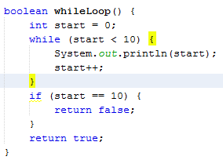We grab properties and methods with dot notation; we can only grab them if they are on our visible scope

$objectName.objectProperty;$

$objectName.objectMethod\left(Method arguments\right);$

#### Conditional Statements and Iterative Loops

* Are $true$ or $false$ statements
  + If/Else statements
    - If a condition is true, run a block of code
    - Otherwise (Else), run a different block
* An iterative loop runs a block of code over and over again until the condition becomes false
  + 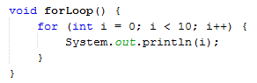While loop – Keeps going until your code changes the conditional (Careful of infinite loops)
  + For loop – Changes the value of an integer on every iteration

Figure - For and While Loops

* Conditional Operators

$booleanValue==false \left| \right| stringValue==\text{thisString} \&\& doubleVal>=1.5$

### Software Architecture

#### Basic Software Architecture

* Runs one function over and over again until that loop is killed by a conditional

#### Our software architecture

Figure - Robot Builder Example File Tree

* Runs on modularized code, so that we do not call the same function over and over again (ours isn’t as redundant)
* Robot Builder modularizes most code automatically, so that we don’t have to manually create every class